Information Security and Cyber Incident Response Procedure

Author | Revision | Comments | Date | Next Review
Mor Aroeti | 1.0 | Initial Creation | 2/27/2026 | 15/01/2027
Dekel Yaacov | 1.1 | English translation, added 24-hour customer notification | 10/1/2026 | 15/01/2027

Review and Approvals

Name | Title | Date
Dekel Yaacov | CTO | 3/10/2026

Table of Contents
1. General 2
1.1. Purpose 3
1.2. Scope 3
1.3. Definition of a Cyber Incident 4
2. Alert Levels 4
2.1. General 4
2.2. 'Green' or 'Low' 4
2.3. 'Yellow' or 'Elevated' 4
2.4. 'Orange' or 'High' 5
2.5. 'Red' or 'Severe' 6
3. Roles and Responsibilities 8
3.1. CEO 8
3.2. CTO 8
3.3. CISO 9
3.4. Technical Incident Response (IR) Team (if activated) 10
3.5. Business Unit Managers 10
3.6. Company Employees 11
4. Principles for Information Systems Response and Recovery 11
4.1. Cyber Attack Scenarios 12
4.2. Principles for Addressing a Cyber Attack Scenario 12
4.3. Principles for Responding to a Cyber Attack Scenario: Methodology 13
5.1. Preparing the Company to Manage Information Security and Cyber Incidents 14
5.2. Initial Stage: Alert and Detection 15
5.3. Stage A: Reporting, Designating the Response Team, Assigning Responsibilities, and Initiating Documentation 15
5.4. Stage B: Triage and Classification of the Incident 15
5.5. Stage C: Analysis and Assessment 16
5.6. Stage D: Containment 18
5.7. Stage E: Eradication 19
5.8. Stage F: Recovery 20
5.9. Stage G: Incident Closure and Lessons Learned 20
5. Principles for Responding to and Handling a Ransomware Incident 20
6.1. General 20
6.2. Types of Ransomware Incidents 20
6.3. Guiding Considerations for Managing a Ransomware Incident and Decision Making 21
6.4. Description of the Handling Process 21
Handling a Ransomware Incident, Stage 1 24
Handling a Ransomware Incident, Stage 2 25
Handling a Ransomware Incident, Stage 3 27
Principles for Responding to and Handling a Malware Cyber Incident 28
7.1. Response to a Malware Incident 30
8.1. Principles for Responding to and Handling a Phishing Cyber Incident 31
8.3. Common Objectives of a Phishing Attack 31
8.4. Typical Types of Phishing Attacks 31
8.5. Response to a Phishing Incident 32
9. Appendix: Communication During a Cyber Crisis 33
10. Applicability of the Procedure 34
11. Communication Stages During a Cyber Crisis 34
Roles and Responsibilities in Crisis Communication 35
Updating, Reviewing, and Improving the Procedure 35
Summary 35
Cyber Incident Reporting and Tracking 35
5.2. Technical Data 41
5.3. Activity Log 42
5.4. Reporting Log 43
5.5. Lessons Learned 44

General

Purpose
    - ENSIGHTS (hereinafter: "the Company") develops a platform for the smart management of solar energy systems.
    - The Company may face crisis and disaster situations of various types, which may affect its operational and business continuity and its ability to meet its commitments to its customers, and may cause financial and reputational damage.
    - Because the Company's operations are fully dependent on its technology platform and cloud environment, special emphasis is placed on the ability to continue providing service to customers even in the event of a failure,
disruption, or attack affecting system availability. This capability is achieved through the use of distributed cloud infrastructure, automated backups, configuration management, and measures for the rapid restoration of the operational environment (Disaster Recovery), while meeting availability and recovery objectives
    - To handle a cyber crisis effectively, a combination of advance preparedness and effective crisis management is required, in a manner that reduces and limits its damage and consequences and shortens its duration.
    - Accordingly, as part of its efforts to build cyber resilience, ENSIGHTS (hereinafter: "the Company") has chosen to define the framework for managing information security incidents at the Company in this policy.
    - This document shall be reviewed annually and updated as needed, or following a material change in the Company's business and operational processes, or following material changes in the infrastructure supporting critical systems.

Scope
    - The principles and courses of action for preparing for and managing crisis situations in the Company's cyber domain.
    - A tool for building a cyber preparedness and response plan, in order to maintain operational and business continuity in the event of a cyber incident.
    - Definition of critical cyber assets.
    - Definition of the various cyber Readiness Levels and the principles for changing Readiness Levels.
    - Definition of the preparedness "toolbox".
    - Definition of the cyber crisis management concept.
    - Definition of the operational concept: the actions required to handle and appropriately respond to a cyber incident.
    - Definition of the need for an implementation procedure (Playbook) for typical attack scenarios.
    - To detail the possible actions for managing, containing, and controlling the incident in order to recover and return to normal operations.

Definition of a Cyber Incident
    - A cyber incident shall be defined as a situation in which one or more of the critical components of the Company's cloud infrastructure, product, or online services ceases to function properly, as a result of damage to the ability of the information systems or cloud services to support continuous business operations.
    - A cyber incident may be caused by deliberate malicious acts (such as cyber attacks or unauthorized access attempts), human error, technical failures in cloud services or in system configuration, or an external outage of critical services by vendors (such as cloud services, DNS, CDN, or data communications).

Alert Levels

General
To prepare for and respond more effectively to cyber incidents, an "alert indicator" is used, which shows the current level of malicious cyber activity based on observed events or actual damage. The indicator consists of three levels:

'Green' or 'Low'
    - Indicates low risk. A situation in which no significant malicious activity has been identified, or no malicious activity has been identified at all, and there is no unusual activity beyond normal vigilance toward known general malicious activities, known viruses, or other malicious activity.
    - Examples:
      - Routine external scans.
      - Known low-risk viruses
    - Response:
      - Continue routine preventive measures, including regularly applying vendor security patches and updates to antivirus signature files.
      - Continue routine security monitoring.
      - Ensure that employees receive appropriate training on cybersecurity policy.
    - Updates and Reporting:
No special notification or update is required.

'Yellow' or 'Elevated'
    - Indicates significant risk due to increased malicious activity, viruses, or other malicious activity that endangers systems or impairs service. At this level, known vulnerabilities are being exploited with a moderate level of damage or disruption, or the potential for significant damage or disruption exists.
    - Examples:
      - A practical method has been published for exploiting a critical vulnerability that exists in the Company's systems and has the potential for significant damage.
      - A critical weakness or vulnerability has actually been exploited but had a low impact on the organization's systems.
      - There is a suspected breach of a system that is not critical or does not contain sensitive information.
      - A distributed denial of service attack is occurring against the Company's corporate website.
    - Response:
      - Immediately complete routine preventive measures, including applying vendor security patches and updates to antivirus signature files.
      - Increase routine security monitoring.
      - Identify systems vulnerable to the identified weaknesses.
      - Immediately implement appropriate countermeasures to protect vulnerable critical systems.
    - Updates and Reporting:
      - The organization's management shall be updated
      - Employees shall be called upon to increase vigilance
      - A meeting of the response team shall be held to review the situation and assess whether the preventive measures taken are sufficient.

'Orange' or 'High'
    - Indicates a high risk of a breach occurring, or other malicious cyber activity targeting or affecting core infrastructure, which may cause service outages, damage to a large number of systems, or damage to a critical system or infrastructure, where the potential for severe damage or disruption is high.
    - Examples:
      - A vulnerability has actually been exploited with significant impact.
      - Attackers have gained a foothold in a system.
      - There are operational disruptions as a result of malicious activity.
      - A significant denial of service attack is occurring against the Company's infrastructure.
    - Response:
      - Increased monitoring of the protection and management systems in order to identify and map any potentially malicious activity
      - Consider disconnecting relevant systems from the internet.
      - Consider disconnecting certain systems from the network and/or shutting them down.
      - Consider sealing/isolating network segments.
      - Prepare to continue operations at reduced functionality using alternative means of communication and telephony.
      - Immediately implement appropriate countermeasures to protect vulnerable critical systems.
    - Updates and Reporting:
      - The organization's management shall be updated immediately.
      - The situation room shall be activated, physically or by telephone
      - A meeting of the response management team shall be held for a situation assessment
      - Consideration shall be given to declaring/activating a disaster/crisis state
      - Employees shall be called upon to increase vigilance
      - A meeting of the technical response team shall be held to review the situation and assess whether the preventive measures taken are sufficient.

'Red' or 'Severe'
    - Indicates a severe risk of a breach, malware intrusion, or other malicious activity resulting in widespread operational disruptions and/or significant damage to critical systems with no known immediate solution. Damage to one or more critical infrastructure processes/systems. At this level, vulnerabilities are being exploited with severe or widespread damage to, or disruption of, critical infrastructure assets.
    - Examples:
      - Outage of the platform or critical systems.
      - Loss/encryption of critical information.
      - Indications of theft/leakage of sensitive information.
    - Response:
      - Disconnection, isolation, and sealing of affected systems/segments
      - Conducting an investigation to identify the intrusion vector and the root cause
      - Identifying the exploited vulnerabilities
      - Identifying the signatures of the malicious code/malware used
      - Identifying the time of intrusion and the most recent backup version preceding that time
      - Weighing system cleanup versus restoration from a backup generation preceding the intrusion
      - Remediating the vulnerability that enabled the intrusion, or disabling the component containing it.
      - Continued increased monitoring of the protection and management systems in order to identify and map any potentially malicious activity
      - Prepare to continue operations at reduced functionality using alternative means of communication and telephony.
      - Immediately implement appropriate countermeasures to protect vulnerable critical systems.
      - Changing administrator passwords if there is any suspicion that they have been compromised.
      - Blocking the accounts of the affected computers in the organizational Active Directory system.
      - Leaving workstations powered on to enable forensics.
      - Activating the IR team.
      - Continuing to operate in a partial state with whatever has not been affected (in accordance with the guidance of the IR experts).
      - Restarting/restoring from backup whatever has been affected, in a controlled manner, after sanitization.
      - As part of the restoration/cleanup process, the following is required:
        - Definitive identification of all affected workstations and/or servers in the organization in order to address them.
        - Conducting a malware analysis process, through forensics experts.
        - Examining the attacker's response to the mitigation efforts carried out by the organization.
        - Preparing a response in advance in case the attacker attempts to carry out an attack from another source (by creating malware signatures, preparing a special attack profile in the IPS system, and special attack rules in the FW).
        - Reinstalling the operating system of every affected computer: system sanitization.
        - Allowing time before making new changes to the network, in order to confirm that the threat has passed.
        - If the organization's domain has been blacklisted, the relevant internet service provider and the blacklist providers shall be contacted in order to have the domain removed.
        - Restarting/restoring from backup all affected systems while performing verification controls.
    - Updates and Reporting:
      - The organization's management shall be updated immediately.
      - The Business Unit Managers shall be updated
      - The situation room shall be activated
      - A meeting of the response management team shall be held for a situation assessment
      - A disaster/crisis state shall be declared/activated
      - The incident shall be communicated to employees
      - A meeting of the technical response team shall be held to review the situation and assess whether the preventive measures taken are sufficient.
      - Consideration shall be given to communicating with customers in a manner, extent, and wording appropriate to the situation.

Roles and Responsibilities

CEO
    - Authority to declare a cyber incident state and activate the response.
    - Managing the business situation room, including setting the public relations and spokesperson policy, setting the policy for negotiation with attackers as necessary, and making decisions that affect the organization's business continuity.
    - Shall receive from the technology team status reports on the state of the systems regarding any change in the cyber criteria and any cyber incident, along with recommendations for implementation.
    - Shall direct the management team regarding the operational and business continuity strategy during the incident.

CTO
    - The Company's readiness to respond to an information security and cyber incident.
    - Directing and managing proactive containment actions, subject to the CEO's approval.
    - Managing the transfer of server center functions to the DR site when so decided.
    - Managing the return of operations to the primary site after the incident ends, while synchronizing the data.
    - Engaging external vendors for the diagnosis, handling, remediation, and restoration of information systems.
    - Performing backups and quarterly testing of their integrity.
    - Conducting tests to locate the source of the incident in cases of functional damage to the computing and communications infrastructure.
    - Carrying out proactive containment actions in accordance with the instructions of the information security manager and with the CEO's approval.
    - Implementing bridges/workarounds for internal and external communication paths as necessary.
    - Restoring from backups as necessary and bringing up new environments free of malware.
    - Executing the transfer of server center functions to the DR site.
    - Returning operations to the primary site after the incident ends, while synchronizing the data.
    - Shall direct the technology team regarding the incident response strategy.

CISO
    - Shall map the threat actors as part of the periodic risk assessment and review the currency of the mapping once a year.
    - Shall define a work plan for preparedness in managing information security incidents and update it at least once a year, in accordance with the risk assessment and the analysis of failure events (extreme scenarios) such as, but not limited to: unauthorized access to Company assets, data leakage, impersonation, privilege escalation, execution of malicious code, malware, fraud, data tampering, phishing, denial of service attacks, and the like.
    - Shall define and ensure the existence of a monitoring and control framework for receiving reports from the Company's various systems regarding a suspected information security incident.
    - Shall define and ensure the use of systems and processes that will detect and alert on activity defined as prohibited or suspicious in the Company's systems. The alerts shall be designed based on the definition of threat scenarios and in accordance with the risk assessment. In addition, shall implement a mechanism for reporting suspicious activity, which shall be accessible to employees.
    - Shall ensure the existence and currency of log retention rules (audit logs) and historical information, which shall be used as necessary for investigation during a cyber incident.
    - Shall investigate and draw lessons learned regarding every cyber incident as required, including conclusions to be implemented within a reasonable period of time from the occurrence of the incident.
    - Where necessary, the incident debriefing will be forwarded to the relevant professional stakeholders for their information and consideration.
    - Plan and ensure the execution of information security incident response drills.
    - Upon completion of each drill, prepare a report for the Information Security Steering Committee.
    - Be responsible for drafting and maintaining up-to-date procedures, working documents (Playbooks), and guidelines related to information security incident management, drills, monitoring, and alerting.

Technology Incident Response (IR) Team (if activated)
    - Assist with the technical analysis of the incident, as well as technical response, containment, cleanup, and recovery, as detailed below.
    - Forensic investigation of the incident, and collection and documentation of evidence.
    - Valid and relevant cyber intelligence regarding the incident, including information on possible malicious code, attackers, vulnerabilities, passwords exposed online, etc.
    - Conduct a rapid investigation, with meticulous documentation and evidentiary collection regarding the attack vector and the security breach that enabled the attack.
    - Assist in identifying and isolating the affected systems and containing the attack.
    - Neutralize and remove malicious code while preserving evidence.
    - Seal off the relevant environments to prevent data leakage.
    - Collect digital forensic evidence during the incident in a professionally valid and legally admissible manner, in order to determine whether the incident is related, accidentally or maliciously, to an external supplier of the Company or to collaboration from within the organization, and also to enable the organization to document, draw conclusions, and gain a complete understanding of the possibility that data was leaked, which may lead to the exposure of sensitive personal information or trade secrets, and of the possible regulatory, legal, and reputational implications.
    - Examine options for returning the organization to normal operations as quickly as possible and recommend a recovery strategy, while presenting the managerial, legal, communications (internal: employees; external: customers, suppliers, media), and operational implications.
    - Provide continuous support and handling throughout all stages of restoring normal operations efficiently and quickly, while minimizing damage and downtime.
    - Conduct a comprehensive incident debriefing, including conclusions and recommendations for action, and submit a report of findings and recommendations.
    - Examine the effectiveness of protective controls in light of the lessons learned from the incident, and recommend corrections or additions where necessary.

Business Unit Managers
    - Company management is responsible for conveying the business implications of a cyber incident to the situation room.
    - Define and activate alternative business processes prior to reaching the "Restoration" stage (return to normal operations), and monitor the execution of these activities.
    - Provide direction regarding changes to the level of specific business activities in accordance with the incident (for example: suspension of a service).
    - Manage the Company's human resources during a cyber crisis.

Company Employees
    - Perform their work in accordance with the Company's information systems and information technology security instructions and guidelines for protection against damage and threats.
    - Report any case or suspicion of a cyber incident.
    - Comply with the organization's guidelines regarding the disclosure of information to internal and external parties.

Principles for Information Systems Response and Recovery

Cyberattack Scenarios
Impact | Description | Information Security Scenario
Legal and regulatory exposure, system downtime, financial damage, reputational damage. | Malware that encrypts and/or steals data and demands payment of a ransom for its restoration and/or non-publication. | Ransomware Attack (Ransomware)
Privacy violation, loss of competitive advantage, lawsuits. | Breaching systems in order to steal personal, financial, or business data. | Data Theft  (Data Breach)
Service downtime, degraded user experience, mitigation costs. | Flooding servers or networks with an enormous volume of requests in order to bring them down. | Denial of Service Attack (DDoS)
Account takeover, data theft, need for data restoration. | Use of phishing or brute force attacks to steal access credentials. | Account and Permissions Compromise (Credential Theft)
Theft of user details, malware distribution, data corruption. | Fake emails or impersonating websites intended to steal sensitive information. | Phishing Attacks  (Phishing & Spear Phishing)
Network intrusion, remote control, exploitation of security gaps. | Attacks through vulnerabilities in operating systems, software, or devices. | Exploitation of Software Vulnerabilities (Exploiting Vulnerabilities)
Intrusion into secured networks through a third party, difficulty in detecting the attack. | Intrusion through software or hardware suppliers in order to attack end customers. | Supply Chain Attacks (Supply Chain Attack)
Leakage of business information, intentional damage to Company systems. | Employees or contractors who exploit internal access to classified information. | Insider Attacks  (Insider Threats)
Execution of fraudulent money transfers, fraud against suppliers and customers. | An attack involving the takeover of a corporate email account for the purpose of committing financial fraud. | Business Email Compromise (BEC)

Principles for Responding to a Cyberattack Scenario
    - Comprehensive information security and cyber policy
    - Maintaining information security and cyber procedures
    - Information security monitoring
    - Routine tracking of information security and cyber trends, activity, and alerts from the various information systems
    - Employee background screening upon hiring
    - Performing a full backup of data and software at the frequency to be determined in the relevant backup procedures.
    - Redundancy of the technology infrastructure for critical systems.

Principles for Responding to a Cyberattack Scenario: Methodology
    - General sequence of actions upon detection of an incident:
      - Upon receiving a report of an information security incident, the CISO or a person appointed by the CISO will act in accordance with the following stages and will document the entire course of incident handling through to the lessons learned stage.

      - As part of managing a cyber incident, activity will be divided into three main efforts for handling the incident, while, as a built-in and integrating component, a cross-functional process of crisis management resulting from the cyber incident is conducted:
- Restoration Effort: focuses on the impact on business continuity
- Defense Effort: focuses on protecting the Company's systems and information
- Investigation Effort: focuses on identification and investigation to determine the depth of the compromise, the nature of the attack, and the entry vector, as described in the following diagram:

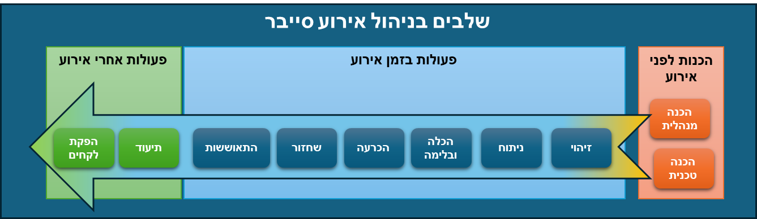

    - The activities described above will be carried out in synergy through the establishment and operation of two leading situation rooms (crisis management):
- Management Situation Room: Executive Conference Room
- Technology Situation Room: Conference Room
    - The rooms will be defined and designated in advance as part of the readiness process for handling a cyber incident, and will be connected to each other in a manner that enables optimal communication, including, among other things, video call capability.

Preparing the Company to Manage Information Security and Cyber Incidents
    - Administrative preparations, including:
      - Training and awareness
      - Employment reliability assessment
      - Procedure development
      - Establishing a response team and defining roles
      - Drills
      - Tracking alerts from the National Cyber Directorate and system vendors
      - Engaging a cyber incident response service provider
    - Technical preparations, including:
      - Backups
      - Alternate disaster recovery site (DR)
      - Technology controls
      - Monitoring controls and receiving alerts
      - Documentation of actions
      - Maintaining and operating investigation tools at the SOC provider
      - Logging of events and actions (logs)
      - Monitoring of systems and indicators (SOC/SIEM )

Initial Stage: Alert and Detection
    - An alert regarding the possibility of a cyber incident may be received based on a variety of early warning signs, including:
    - Information on the spread of new vulnerabilities and malware
    - Logs from management and security systems
    - Activity on or toward the network
    - Identification of suspicious email(s)
    - Indications of information gathering on the network and systems, such as port scanning, etc.
    - An alert regarding the possibility that a cyber incident is already occurring in the Company's systems may be received based on indicators from the Company's protection and management systems, including:
    - Alerts from security systems
    - Alerts from antivirus systems
    - Alerts from endpoint protection systems
    - Alerts from email protection systems
    - SIEM alerts
    - Users

Stage A: Reporting, Establishing the Handling Team, Assigning Responsibilities, and Initiating Documentation
    - Initial reporting to the CTO, who will designate the person initially responsible for handling the incident.
    - The person responsible for handling the incident, or a person appointed by them, will document the entire course of incident handling through to the lessons learned stage, including details of the users, the handlers, the findings, the phenomena that occurred, and the handling methods.
    - Activation of the initial team and assignment of tasks.

Stage B: Triage and Classification of the Incident
    - The technical team, led by the CISO, will analyze the indicators and warning signs in order to classify the type and severity of the incident.
    - Possible incident types:
      - Disruption of external supplies: cloud data center.
      - Technical failure in critical computer hardware.
      - Technical failure in critical security system hardware/software.
      - Technical failure in a critical information system.
      - Impairment of system availability or integrity as a result of a malicious external attack.
      - Theft of sensitive information by a malicious external party.
      - Accidental leakage of sensitive information by an internal party.
      - Intentional leakage of sensitive information by an internal party.
      - Severity levels:
      - Partial impairment / outage of a critical process.
      - Complete impairment / outage of a critical process.
      - Complete impairment / outage of multiple critical processes.
      - Complete impairment / outage of a customer-facing system
    - Situation assessment:
      - The technical team will present the facts known at this stage, their analysis, and the classification of the incident in terms of its type, scope, and severity.
      - The CTO, in consultation with the CISO, will perform an initial situation assessment of the possible business impacts of the incident and will recommend whether there is a need to declare a cyber incident and activate the response plan.
      - The CEO will decide whether to declare a disaster / crisis state and will approve the activation of the proposed response plan.
    - Reporting:
      - The CTO will formulate a proposal for the scope and wording of reporting to internal parties within the organization, according to the type, scope, impact on users and employees in the organization, and severity of the incident.
      - The CTO will formulate a proposal for the scope and wording of reporting to external parties (if at all at this stage), according to the type, the scope of impact on external parties, the possibility of uncontrolled publication, regulatory obligations, and the severity of the incident.
      - The CEO will decide on the scope of reporting and will approve the proposed wording for the various stakeholders.

Stage C: Analysis and Assessment
    - The technical team, led by the CISO and assisted by a specialized response and forensics team, will analyze the data and records (logs) from the organization's protection and management systems in order to identify the root cause of the incident and map the scope of its impact, including:
      - Conducting an investigation to identify the intrusion path
      - Identifying the exploited vulnerabilities
      - Identifying the signatures of the malicious code / malware used
      - Identifying and analyzing traffic that may indicate data leakage
      - Identifying addresses and information assets exposed to the incident
      - Identifying the time of intrusion and the existence of a valid backup version predating that time
      - Mapping the affected systems
      - Mapping the affected information in terms of its sensitivity and/or criticality.
    - Formulating a proposed Containment strategy, including:
      - Blocking suspicious traffic
      - Disconnecting systems and information assets from the network
      - Isolating network segments
      - Disconnecting systems from the internet
      - Changing passwords and blocking accounts
      - Shutting down systems and services
    - Situation assessment and approval of the Containment plan:
      - The technical team will propose the Containment plan, including the operational impacts on the level of functionality and availability of the critical business processes.
      - The CTO and the Business Unit Managers will present the expected business impacts.
      - The CEO will decide on the approval of the Containment plan and measures.
    - Reporting:
      - Company management will formulate a proposal for the scope and wording of reporting to internal parties within the organization, according to the type, scope, and impact of the Containment measures on users and employees in the organization.
      - Business Unit Managers will instruct and brief their employees on how to operate business and functional processes during the isolation and Containment state.
      - Company management will formulate a proposal for the scope and wording of reporting to external parties who will be affected by the Containment measures, such as sales personnel, customers, etc., according to the type and scope of the impact.
      - In an incident that may have an impact on a significant number of external parties, such as customers, consideration should be given to engaging public relations consultants regarding the need for and wording of the report.
      - The CEO will decide on the scope of reporting and will approve the proposed wording for the various stakeholders.

Stage D: Containment
    - The response team will implement the approved Containment plan.
    - The objective of this stage is to gain control over the incident in order to contain it, stop its escalation/spread, and prevent it from continuing to achieve its objectives.
    - The containment measures are required to take control of the attack infrastructure within the Company, in order to completely stop the attack vector. In addition, containment of the damage-causing processes occurring in a cyber incident yields one or more of the following outcomes: 1) delimiting the scope of the damage-causing process in terms of space or physical means; 2) limiting the severity of the damage caused to below a certain threshold.
    - The Containment stage must be accompanied by continued monitoring of the organization's protection, communication, and management systems in order to verify that there are no additional intrusion paths, other / additional malicious code not yet discovered, or other compromised information assets.
    - Situation assessment:
      - The technical team will report on the degree of success of the Containment measures, the degree of control over the attack paths, and the containment of further spread of the damage.
      - The forensic investigation team will provide updates on findings regarding data leakage, its scope and type, identification of the attack tools, and an assessment identifying the type of attacker and the objectives / motives of the attack.
      - Business Unit Managers will provide updates on the impact of the incident on business processes, customer and supplier relationships, etc.
      - The technical team will present the practical implications of choosing the "Eradication" alternative, namely the removal of malware and attack tools, as opposed to an immediate transition to Recovery by restoring information from reliable backups to a new environment to be established at the primary or alternate hosting site.
      - The main guiding considerations will be:
        - The existence of reliable evidence regarding the time of the initial intrusion of the malware.
        - The existence of reliable and valid backups from before the verified time of intrusion.
        - The time gap, the amount of information that will be missing, and its criticality to the business process.
        - Backup restoration time versus cleanup time.
    - Reporting:
      - Update on the incident type (data leakage, data encryption, outage, etc.).
      - Update on the type and amount of information leaked or encrypted / deleted
      - Update on the affected systems / services and the extent of the damage
      - Whether there is a ransom demand: identification and assessment of the nature and type of the attacker
      - The actions planned for Recovery and an estimated timeline for their completion
      - Have the intrusion path and attack tools been identified and neutralized?
      - The existence of valid and tested backups, and the date of the last valid backup.
      - Recommendations for a Recovery strategy.

Stage E: Eradication
    - The forensic team will scan the systems and eradicate malware and attack tools.
    - The DevOps team will apply security updates and configuration fixes to block the vulnerabilities identified in the cloud environment.
    - Available security updates will be applied to systems and infrastructure.
    - Protection systems will be updated to block the traffic, addresses, and identifiers that were discovered.
    - The DevOps team will implement the approved Containment plan.
    - Reinstallation of operating systems should be considered.
    - Perform a repeat scan of the systems to verify the absence of malicious code and vulnerabilities.
    - Reporting:
      - Results of the scans for detecting malware identifiers.
      - Which systems have been successfully cleaned, tested, and approved for operation.
      - Which backups have been tested and approved for use.
      - Which required system updates and security updates have been completed.

Stage F: Recovery
    - Implementation of the Recovery strategy.
    - Determining the prioritization of systems and information.
    - Reinstallation of operating systems, servers, and databases affected by the incident.
    - Restoration of information from verified and reliable backups.
    - Integrity checks.
    - Phased return to routine operations.

Stage G: Incident Closure and Lessons Learned
    - Complete full documentation of the incident.
    - Assess the impact of the incident on the Company:
      - Loss of information and its business and financial impact
      - Leakage of sensitive information and its impact in regulatory, business, and reputational terms.
      - The cost of handling the incident.
      - Cost / damage resulting from the disruption of essential processes.
      - Impact on customers, suppliers, and business partners.
      - Develop a summary report and distribute it to stakeholders subject to CEO approval.

Principles for Responding to and Handling a Ransomware Incident

General
    - Cyberattacks for the purpose of ransom extortion have been widespread for many years, becoming increasingly sophisticated and spreading to many diverse business, public, and industrial sectors.
    - The financial motive has given rise to a market in which criminal actors offer access permissions, attack tools, and even the execution of the attack itself in exchange for payment.
    - Cyber incidents for the purpose of ransom extortion have unique characteristics due to the uncertainty regarding the attacker's true and full intentions in both the immediate and long term.
    - These characteristics make the process of managing this type of incident, and the related decision-making, particularly complex and challenging.

Types of Ransomware Incidents
    - An attack involving the malicious encryption of information and systems essential to the organization's functioning, in a manner that disrupts the organization's business and operational activity. The encryption keys for the information are offered in exchange for a ransom payment.
    - Theft of sensitive personal or business information and a threat to publish the information if a ransom is not paid.
    - An attack combining the theft of sensitive personal or business information, immediately followed by the malicious encryption of information and systems essential to the organization's functioning, in a manner that disrupts the organization's business and operational activity. In these cases, the ransom is demanded separately or jointly for receiving the encryption keys and for the non-publication of the information.

Guiding Considerations for Managing a Ransomware Incident and for Decision-Making
    - The scope, type, and criticality of the systems disrupted by encryption.
    - The existence of valid and reliable backups that can be determined with certainty to be unaffected.
    - Recovery time from backups.
    - The extent of the financial, operational, and reputational damage that will be caused to the Company during the disruption until restoration from backups, to the extent such backups exist.
    - If information was stolen: the type of sensitivity (personal, business, proprietary, etc.), its degree of sensitivity, and the scope and quantity of the information stolen.
    - Regulatory and legal exposures.
    - Identification of the attacker, the existence of information about the attacker, the attacker's motives, and the existence of historical information regarding the attacker's reliability in not publishing information or providing keys after the ransom is paid.
    - Proof that the information is indeed in the possession of the party demanding the ransom.
    - Proof that the party demanding the ransom possesses the encryption keys.
    - The amount of the ransom demanded.
    - Policy, ethical, and organizational sensitivity considerations.
    - Whether the organization has the practical ability to pay the ransom (digital currency wallet, amount).
    - Should negotiations be conducted? If so, by whom and how?
    - What assurances should be demanded (a key for certain files as proof)?
    - Is insurance approval required?
    - What is the probability that paying the ransom will prevent the publication of the exposed data?

Description of the Handling Process
    - Incident Identification and Reporting
- Identification of the attack by monitoring systems, user reports, security alerts, or a ransom demand.
- Activation of the Cyber Security Incident Response Team (CSIRT).
- Assessment of the type and scope of the incident: which systems / computers were affected, encryption only, information theft only, or a combination of both.
- Isolation and Initial Assessment
    - Disconnection of infected systems from the network.
- Checking whether critical services have been affected.
- Analysis of the ransomware type (what type? are decryption tools available?).
- Assessment of the availability of valid backups (up to date and not encrypted).
    - Continued Handling Based on Backup Status
      - Scenario 1: A valid backup exists and can be restored
- Verification that the backups are not infected.
- Secure restoration of the systems.
- Removal of malware and a security review.
- Incident analysis and learning for future prevention.
- No ransom payment is required.
      - Scenario 2: No valid backup exists or the backups are encrypted
- Attempting to use free decryption tools.
- Examining the possibility of negotiating with the attackers.
- Legal and business analysis: can the Company operate without the information?
- Making a decision regarding ransom payment.
    - Making a Decision Regarding Ransom Payment
      - If it is possible to restore data without payment:
- No payment is required.
- Proceed to the restoration and security hardening stage.
      - If there is no way to restore and there is severe damage to the business:
- Engage experts to negotiate with the attackers.
- Assess the attackers' credibility (whether they provided proof of restoration capability).
- Verify the legality of ransom payment in the relevant jurisdiction.
- If a decision is made to pay: execute the payment in a controlled and secure manner.
- Obtain a recovery key (if possible).

    - Restoration, Investigation, and System Hardening
      - Investigation of the source of the breach: the vulnerabilities that led to the attack.
- Strengthening the security policy: updating access controls, two-factor authentication, data encryption, and remediation of code vulnerabilities
- Employee training: threat awareness and cyber hygiene.
- Improving backup management: transitioning to immutable/offline (air-gapped) backups.
- Periodic penetration testing: to prevent future attacks.

Ransomware Incident Handling Stage 1
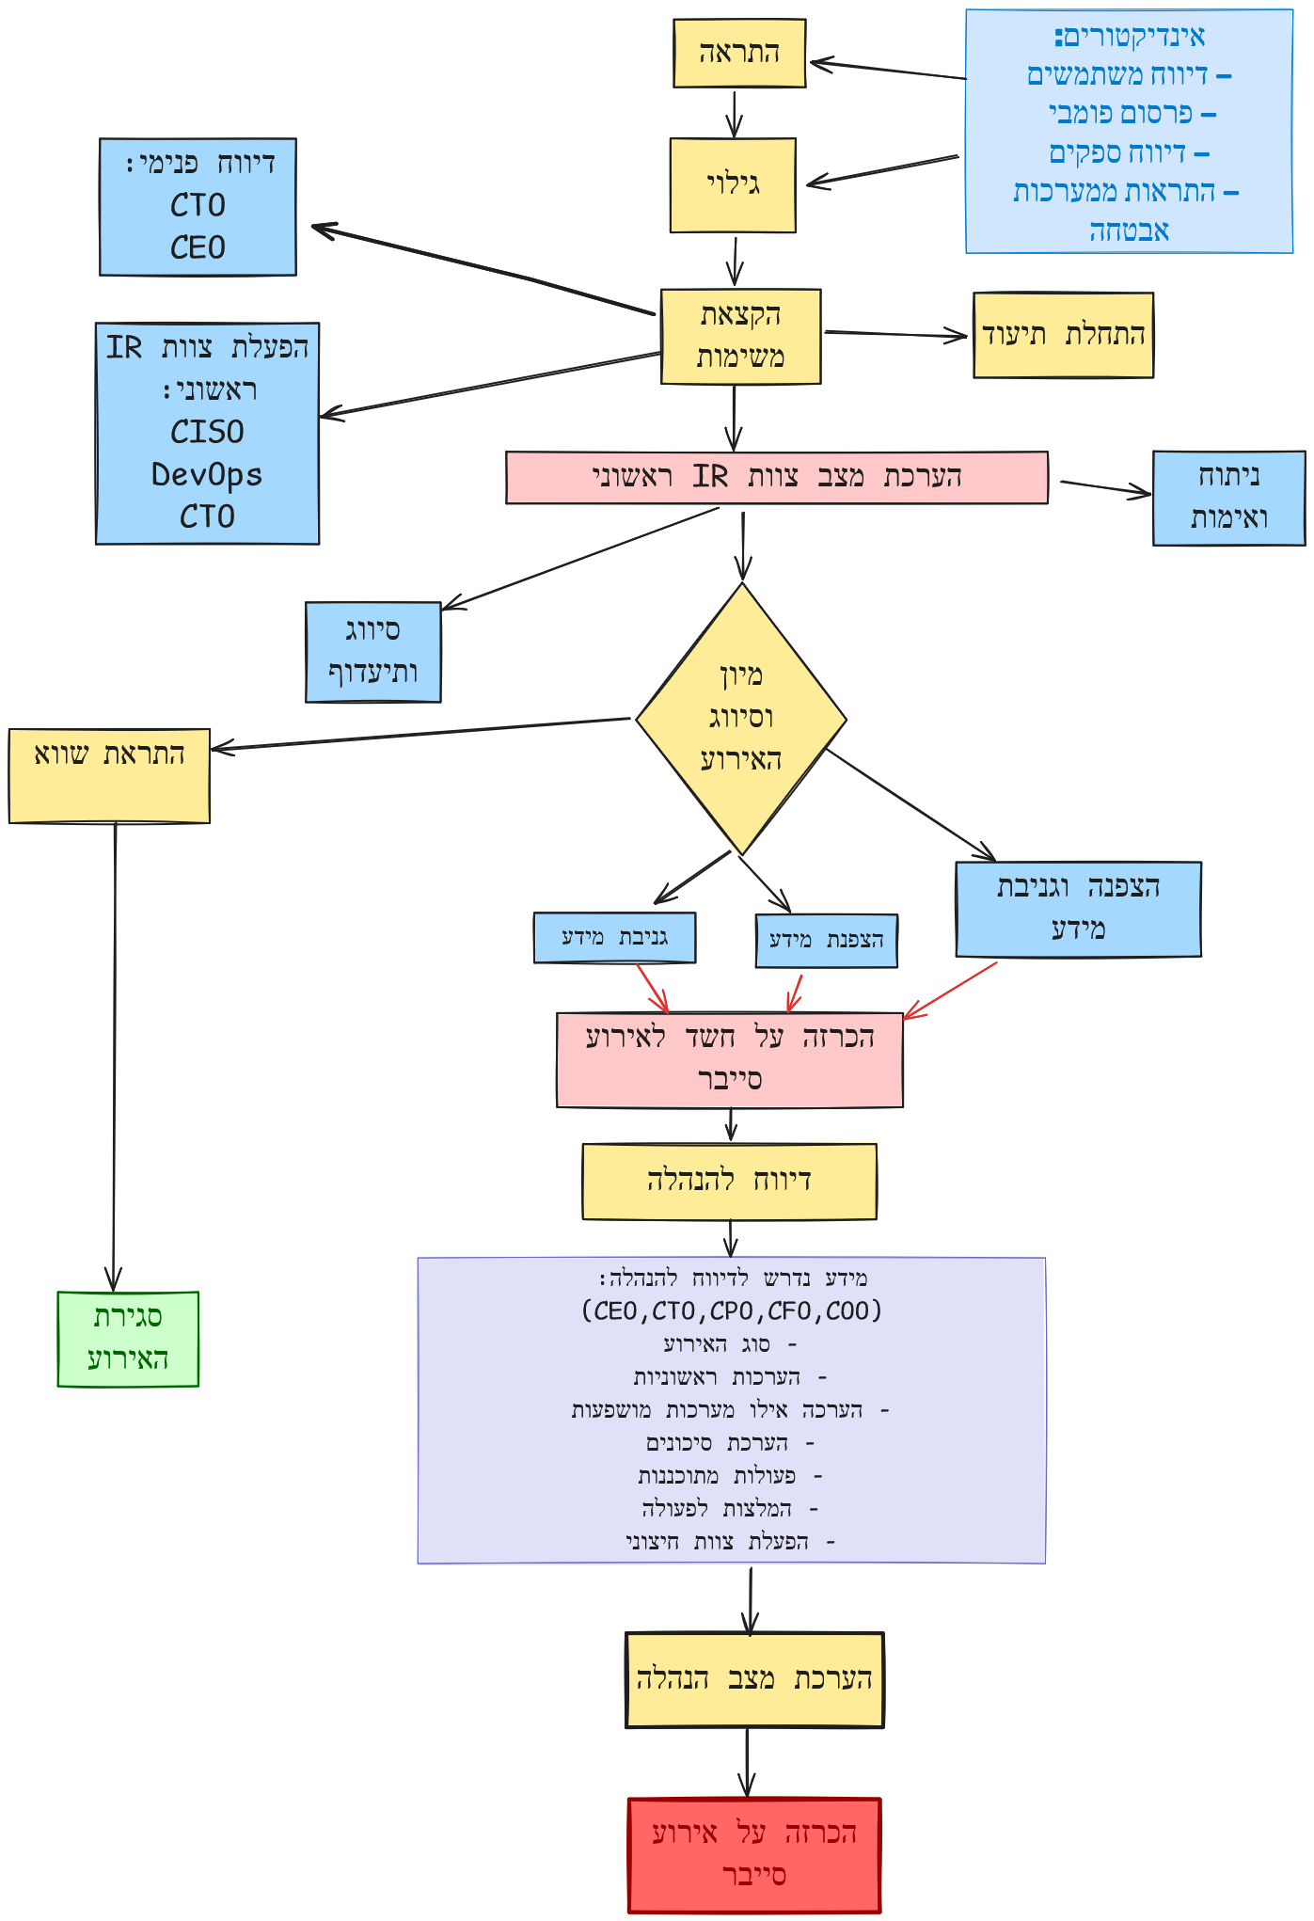

Ransomware Incident Handling Stage 2

Ransomware Incident Handling Stage 3
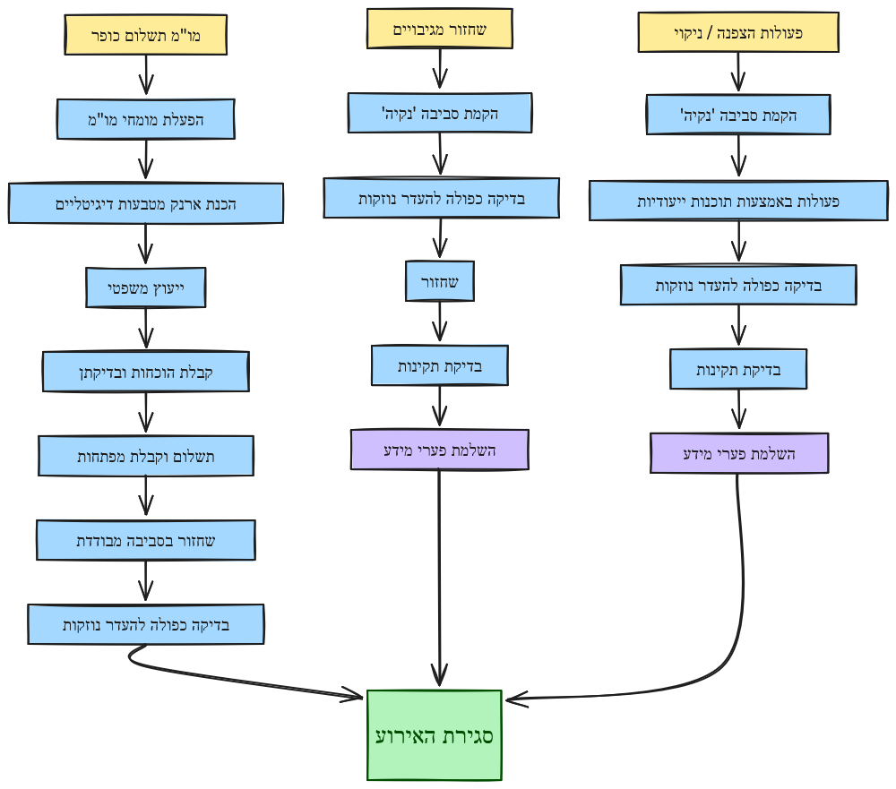

Principles for Responding to and Handling a Malware Cyber Incident

A malware incident occurs when malicious software penetrates a computing system and performs unauthorized actions such as stealing information, disrupting activity, or causing damage to information and systems.
Common types of malware:

Malware Type | Description | Common Impacts
Virus | A malicious file attached to legitimate files that spreads when the user executes it. | Data corruption, system slowdown, and impairment of system reliability.
Worm | Malware that spreads independently without requiring any action by the user. | Spreads automatically between clusters or regions, consumes resources abnormally, disrupts services, and requires components to be taken offline.
Trojan Horse | Malware disguised as innocent software in order to induce the user to execute it. | Installs backdoors, steals information, is injected as innocent-looking code into serverless services or containers, gains unauthorized access to cloud resources, and takes over permissions and critical resources.
Spyware | Software installed without the user's knowledge that collects personal or organizational information. | Spies on user activity, leaks sensitive information from SaaS services and cloud storage, collects information about the cloud structure and permissions, and causes harm to privacy and regulatory compliance.
Ransomware | Malware that encrypts files and demands a ransom for their release. | System disruption, ransom payment demands, loss of data without backup, and encryption of files in storage services such as S3.
Cryptojacking | Malware that uses system resources to mine cryptocurrencies without the user's knowledge. | Exploits cloud resources for coin mining, dramatically increases operating costs, and causes service slowdowns and performance degradation.
Botnet Malware | A network of infected computers controlled remotely for the purpose of cyberattacks. | Denial of service (DDoS) attacks, sending spam, and performance degradation.

Key characteristics of a malware incident:
Penetration and infection:
- Downloading an infected file from a malicious website or phishing email.
- Exploitation of security vulnerabilities in software, operating systems, or cloud services (such as an unprotected API or configuration exposures).
- Connecting an infected device such as a USB drive or other portable device.
- Use of excessive access permissions (Over-privileged IAM roles) or leaked access keys (Access Keys Leak).
- Implanting malware through a Docker image or third-party code in the CI/CD pipeline.
Spread within the system:
- Copying infected files to system folders or a shared Volume.
- Creating connections to the organizational network and lateral movement within a Kubernetes cluster or between regions (VPC Peering).
- Installing backdoors for future control, including creating hostile Lambda functions or Scheduled Tasks in the cloud.
- Using metadata services to steal temporary credentials in a cloud environment.
- Moving between tenants or accounts through trust relationships or token abuse.
Execution of malicious actions:
- Encrypting files in cloud storage services (for example, S3) and demanding a ransom.
- Exploiting system resources (CPU, GPU) to carry out DDoS attacks or mine digital currencies (Cryptojacking).
- Using the cloud infrastructure as a botnet to launch additional attacks, send spam email, or distribute additional malicious code.
- Changing the settings of security services (such as Security Groups, WAF, or CloudTrail) to cover tracks and prevent detection.

Response to a Malware Incident
    - Detection and initial reporting:
      - Identification of a suspected infection through security alerts, user complaints, or monitoring of suspicious activity.
      - Immediate isolation of suspected systems, including disconnection from the network and restriction of access permissions.
      - Reporting to the information security team and Company management.
    - Threat Assessment and Characterization
      - Identification of the malware type (virus, worm, spyware, Trojan horse, etc.).
      - Locating the source of infection and the extent of damage to systems.
      - Assessment of business risk and the impact on operational and business continuity.
    - Threat Containment and Removal
      - Blocking entry points and disconnecting infected components.
      - Running scanning tools and removing the malware in a controlled manner.
      - Correcting system settings and updating software to prevent re-infection.
    - Data Restoration and Integrity Verification
      - Verifying the integrity of backups and restoring data as necessary.
      - Verifying complete removal of the malware and returning the systems to operation.
      - Identifying additional vulnerabilities and strengthening security mechanisms.
    - Documentation, Lessons Learned, and Security Improvement
      - Incident analysis and log review to identify the source of the breach.
      - Updating procedures, strengthening security controls, and improving response processes.
      - Training teams on identifying and preventing future infections.

Principles for Responding to and Handling a 'Phishing' Cyber Incident (Phishing)
  - A phishing incident is a fraud attempt intended to obtain sensitive information such as access credentials or financial information, or to distribute malware, by impersonating a trusted source. These attacks may lead to data exposure, penetration of critical systems, and severe operational and business damage. This chapter describes the recommended response stages in the event of a phishing incident in the organization.

Common Objectives of a Phishing Attack
Objective | Description
Malware Injection | An attempt to induce the victim to download and execute a malicious file, usually as an email attachment or through a malicious link.
Credential Theft | Redirecting the victim to a fake login page in order to collect access credentials for critical systems.
Harvesting Personal and Business Information | Collecting financial data, sensitive business information, or personal information about employees and customers.
Committing Financial Fraud | Impersonating a legitimate organization or administrative party in order to persuade the victim to make fund transfers.
Penetration of the Organizational Network | Gaining access to the organization's networks for the purpose of collecting information or penetrating additional systems.
Use as a Springboard for Advanced Attacks | Gaining initial access in order to deploy additional malware such as ransomware or APT (Advanced Persistent Threat) attacks.

Typical Types of Phishing Attacks
Type | Description
Standard Phishing | Sending fake email messages with links to impersonating websites in order to collect sensitive information.
Spear Phishing | A targeted attack against a specific person or organization, using real details in order to appear legitimate.
Whaling | Targeted phishing that appears to be sent by senior executives or influential figures in the organization.
Vishing (Voice Phishing) | Use of phishing techniques via phone calls to persuade victims to disclose personal information.
Smishing (SMS Phishing) | Sending fake text messages containing links or fraudulent instructions.
Clone Phishing | Cloning a legitimate email and modifying it to include malicious links or infected files.
Angler Phishing | Exploiting social media platforms to impersonate customer service in order to collect personal information.

Response to a Phishing Incident
    - Identification and initial reporting:
      - Identification of a suspicious email, phishing message, or fake website imitating a legitimate source.
      - Immediate reporting to the information security team through a dedicated channel.
      - Isolation of the suspicious message and prevention of its distribution to additional employees.
      - Documentation of every relevant detail: date, time, sender address, suspicious links, and actions taken.
    - Threat analysis and verification:
      - Checking the sender address, attached links, and files.
      - Using cyber tools to analyze the content and identify malware.
      - Reviewing the communication history of users who were in contact with the attacker.
      - Examining the extent of the damage: whether accounts were compromised and whether a malicious file was downloaded.
      - Email Header Analysis:
        - Checking the sender's actual address (Return Path, SPF, DKIM, DMARC).
        - Analyzing IP addresses in the transmission chain (Received Headers).
        - Identifying message manipulations (X-Headers, MIME Type, Encoding).
        - Checking the reputation of the sender address and IP using tools such as VirusTotal, Cisco Talos, MXToolbox
      - Checking for suspicious login attempts to the organization's systems.
    - Containment and removal:
      - Blocking the sender addresses and suspicious websites.
      - Revoking access to compromised accounts and changing passwords.
      - Updating email filters and security systems to prevent further attacks.
      - Locating and removing suspicious files downloaded from the phishing emails.
      - Adding indicators to the advanced protection and monitoring mechanisms to detect repeated attempts.
    - Recovery and damage management:
      - Checking for suspicious activity on organizational accounts and resources.
      - Notifying users who were in contact with the malicious email.
      - Enabling two-factor authentication (MFA) as necessary.
      - Updating regulatory teams in the event that sensitive information was compromised.
      - Checking whether organizational information has leaked to the dark web (Dark Web Monitoring).
    - Investigation and lessons learned:
      - Comprehensive analysis of log data to identify the source and path of the attack.
      - Reviewing user behavior and communications conducted with suspicious parties.
      - Producing an incident report with recommendations for improving security.
      - Training employees to identify and neutralize future phishing attempts.
      - Improving monitoring and alerting mechanisms for early detection of similar attacks in the future.

9. Appendix: Communication During a Cyber Crisis
This procedure defines the internal and external communication processes in the event of a cyber crisis in the organization. Its purpose is to ensure a rapid, transparent, and well-managed response to minimize the reputational, operational, and legal damage to the organization, while complying with regulations and information security requirements.
9.1 Define clear communication channels for handling cyber incidents.
9.2 Ensure that all relevant parties in the organization receive reliable and accurate information in real time.
9.3 Prevent the dissemination of incorrect or unauthorized information that could aggravate the crisis.
9.4 Ensure compliance with regulatory and compliance requirements (such as the Israeli Privacy Protection Law and Regulations).
9.5 Maintain the trust of the public, customers, and business partners through effective communication management.

10. Applicability of the Procedure
This procedure applies to all cyber incidents with an operational, regulatory, or reputational impact on the organization, such as:
    - Breach of information systems
    - Leakage of sensitive personal or business information
    - Ransomware attacks (Ransomware Attack), both in cases of data encryption and in cases of data theft accompanied by threats of publication.
    - Shutdown of critical systems as a result of an attack
    - Publication of incorrect or false information as a result of an attack

11. Communication Stages During a Cyber Crisis
Initial Assessment Stage (0-2) hours from incident detection
- The technology team will identify and verify the incident.
- The Chief Information Security Officer (CISO) will activate the Incident Response Team (IRT).
- Documentation of initial incident details, including affected systems and the extent of the impact.
- Activation of internal communication channels for senior managers and IT teams
Initial Internal Notification (2-4) hours from incident detection
- Urgent notification to senior managers and the Incident Response Team.
- Determination of the incident severity level (Low / Medium / High / Critical).
- Distribution of instructions to employees and users (if necessary, such as changing passwords or disconnecting from the network).
- Convening an emergency meeting with the Incident Response Team.
Notification to Customers and Business Partners
- Affected customers receive written notice within 24 hours of incident detection at the latest, and immediate notice in the case of an active compromise of their data or services.
- Drafting an official statement to customers and suppliers in the event that business information has been compromised.
- Use of email channels, notices on the Company website, and social networks as needed.
- Ensuring transparency and providing accurate information about the situation and the measures taken.

Roles and Responsibilities in Crisis Communication
Role | Responsibility
CEO | Making decisions regarding external publication and handling reputational crises
Legal Counsel | Initiating and approving publications to prevent legal exposure and ensure regulatory compliance
COO | Managing communication with employees and internal instructions during the crisis
CTO | Managing the DevOps team, restoring systems, and leading technological recovery,  responsible for technical response and shutting down systems when necessary
CISO | Making information security decisions and distributing internal instructions
SOC Team & Incident Response Team | Monitoring, investigating, and reporting incident findings to management

Updating, Reviewing, and Improving the Procedure
- Conducting an incident analysis (Post-Incident Review) after every crisis.
- Updating the communication procedures and drawing lessons learned accordingly.

Summary
This procedure ensures orderly, coordinated, and accurate communication during a cyber crisis affecting the cloud environment, while minimizing damage and maintaining the trust of customers, employees, and regulators. The organization's response teams are required to act in accordance with this procedure in order to handle future incidents optimally.

Cyber Incident Reporting and Tracking

Cyber Incident Reporting and Tracking Form
General
Internal Incident Number
Incident Status | Select an item.
Can the incident be shared? | Indicate whether the information may be shared with external parties, for example: government bodies such as the Israel National Cyber Directorate, CERT, the Israel Police, the Israel Securities Authority, customers
Investigation Details
Date Completed | Click or tap here to enter a date.
Investigator Name
Department/Unit
Role
Email Address
Contact Phone Numbers | Main | Mobile | Other
Reported to the CISO? | Yes / No | Report Date | Report Time

Incident Information
Incident Start Date and Time | Click or tap here to enter a date.
Incident Detection Method | Select an item.
Incident Reporter | If reported by an employee, indicate the reporter's name, role, organizational unit, and company; otherwise indicate not applicable
Incident Location | Indicate building, floor, organizational unit, cloud/endpoint
Incident Manager | Indicate the manager's name, role, organizational unit, and company
Incident Description | Clearly describe the incident, the parties involved, the impact on the organization, and any other information that is or will be required for further investigation and lessons learned
Incident Type | Select an item.
Attack Vector | Select an item.
Severity Level | Select an item.
Risk of sensitive data leakage? | ☐ The incident involves a risk of data leakage  If the risk exists, report immediately to the Company's Privacy Officer
Affected Information Systems | Specify, if relevant.
Other Affected Information Assets | Specify, if relevant.
Impact on Company Units and Ongoing Operations | Specify, if relevant.
Was the incident classified as significant according to Company procedures? | ☐ Yes | ☐ No
Does the incident require reporting to the Israel Police? | ☐ Yes | ☐ No

Resolution Description, Incident Closure
Date and Time |  | Click or tap here to enter a date.
Details |  | Clearly and briefly describe the actions taken to handle the incident, and specify which follow-up actions must be performed to prevent similar incidents from recurring or to reduce the likelihood of their recurrence
Appendix: Sensitive Data Leakage
Description of the Leaked Sensitive Information | Briefly describe the nature of the leaked sensitive information
Owner of the Database Associated with the Leaked Information | Indicate the name of the database and the name of its owner from which the sensitive information leaked, as registered with the Privacy Protection Authority (Israeli Law, Information and Technology Authority)
Number of Leaked Records | Indicate the number of sensitive information records that leaked
Indications of Public Disclosure | Indicate whether any indications were identified that the leaked sensitive information, in whole or in part, has been publicly disclosed
Decision on Reporting to Authorities
Entity | Reported? |  | Decision Maker | Report Date and Time
Privacy Protection Authority | ☐ Yes No☐ |  |  | Click or tap here to enter a date.
Israel Police | ☐ Yes No☐ |  |  | Click or tap here to enter a date.
Decision on Reporting to Business Partners
Entity | Reported? |  | Decision Maker | Report Date and Time
 | ☐ Yes No☐ |  |  | Click or tap here to enter a date.
 | ☐ Yes No☐ |  |  | Click or tap here to enter a date.
 | ☐ Yes No☐ |  |  | Click or tap here to enter a date.

Technical Data
Information / Data: Attacking Computer
IP Address / Range | Asset/Server Name | Operating System | Ports Involved | System Nature/Function
Information / Data: Attacked Computers
IP Address / Range | Asset/Server Name | Operating System | Ports Involved | System Nature/Function

Activity Log
Incident Handling Details (indicate actions taken and time)
Date and Time | Describe Actions Taken | Performed By
Click or tap here to enter a date.
Click or tap here to enter a date.
Click or tap here to enter a date.
Click or tap here to enter a date.
Click or tap here to enter a date.
Click or tap here to enter a date.
Click or tap here to enter a date.
Click or tap here to enter a date.
Click or tap here to enter a date.
Click or tap here to enter a date.
Click or tap here to enter a date.

Reporting Log
Incident Reporting to Various Parties
Report Date and Time | Reporting Party | Report Recipient | Report Details
Click or tap here to enter a date.
Click or tap here to enter a date.
Click or tap here to enter a date.
Click or tap here to enter a date.

Lessons Learned
Conclusions to learn and draw from the incident: Preserve / Improve
Function | Description | Details | Preserve / Improve
Team Performance | Did the team perform optimally during the incident? |  | Select an item.
Team Performance | Was the conduct in accordance with Company procedures?
Procedures | Were the procedures adequate?
Alert | Was the alert received in time?
Alert | Was the information received sufficient?
Actions | Were the actions taken erroneous and/or incorrect (was damage caused)?
Actions | Could the incident have been managed differently?
Actions | What actions (if any) were defined for improvement, who is responsible for carrying them out, and by what date?
Reporting | Can the reporting to other parties be improved?
Remediation | What compensating controls or actions could have prevented the incident or its recurrence in the future?
Detection | Are there identifiers / indicators that can be monitored or tracked in the future in order to detect a similar incident?
General | Free text field

